**Protoge**

The goal form this lab is to have the basic knowledge about class and object constraints

* Disjoint classes
* Existential Constraint



* Universal Constraint
* Cardinality Constraints

O Minimum

o Maximum

o Exact

**Step by step example:**

**Structure**

Example 1)

1. Class **person** that holds two data properties (name, email)
2. Class **Students** which is subclass of **Person** with one more data property

(Student num.)

1. Class **Professor** which is

Subclass of **Person** with one more data property

(Research field)

1. Class Lecture that holds two data properties (lecture num.,topic)

e. An object property (attend) relates between a Student and a Lecture

f. An object property (holds) relates between a Professor and a Lecture

**Constraints:**

* Define class lecture and Person as disjoint classes.
* Any student must attend at least one lecture.
* Any Professor must hold at least 2 lectures and at most 5 lectures.

**Example 2)**

**Step 1:**

**Classes:**

Define classes and their hierarchy:

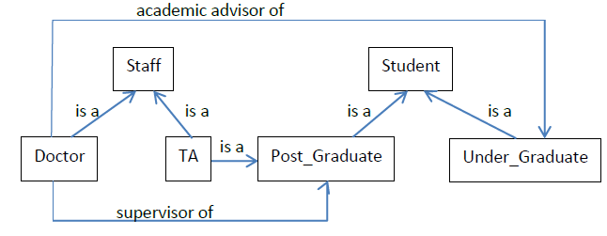

a- Create class Staff as a subclass of Thing (Abstract).

b- Create class Student as a subclass of Thing (Abstract).

c- Create class Doctor as a subclass of Staff (Concrete).

d- Create class TA as a subclass of Staff and Post_Graduate (either by

dragging or through superclass pane) (Concrete).

e- Create class Post_Graduate as a subclass of Student (Concrete).

f- Create class Under_Graduate as a subclass of Student (Concrete).

**Step 2:**

**Data Properties:**

Define slots of each class:

1. Staff (name, salary, Department, job-title). (create in slots tab,

then add slot to class in classes tab)

b- Student (name). (just add the slot as it’s already created)

c- Under_Graduate (level, GPA).

d- Post_Graduate (type).

e- Doctor (degree).

**Step 3:**

**Properties Facets (Constraints)**

a- name: string.

b- salary: float, min. 0, max 100000.

From class expression tap “ Salary some xsd:float[>=0 , <=100000]

c- job_title: string.

d- Department: symbol, allowed values: CS,DS,IS,IT

1. From class expression tap “Department value "$CS$" or

Department value "$IT$" or Department value "$IS$" or Department value "$DS$" “

e- level: symbol, allowed values:1,2,3,4.

f- GPA: float, min 0, max 4.

g- type: symbol, allowed values: msc or phd.

h- degree: symbol, allowed values: Teacher, Associate Professor,

Professor.

**Step 4:**

**Instances:**

a- Go to instances tab.

b- Add 2 instances to TA class:

- TA1, salary 20,000, IS, Teacher Assistant

- TA2, salary 15,000, CS, Assistant.

c- Add 3 instances to Undergraduate class:

Un1, GPA 2.5, level 2.

Un2, GPA 2.7, level 4.

Un3, GPA 3, Level 3.

d- Add 2 instances to Doctor Class:

Doc1, salary 35,000,Professor,IS.

Doc2, salary 30,000, Associate Professor, CS.